

UNIVERSITY OF PETROLEUM AND ENERGY STUDIES
SUB-OBJECT ORIENTED PROGRAMMING
PROJECT DOCUMENTATION
TOPIC-ECOTRACK( CARBON FOOTPRINTS)
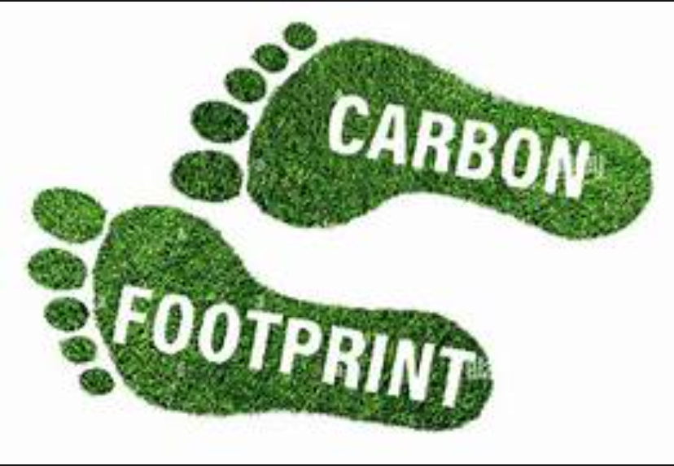

UNDER THE GUIDANCE OF
MR.RAJESH BHATT
GROUP -A (SUBGROUP -3)
MEHIR SAXENA (500123380)
HIRAL MITTAL
MADHUR SRIVASTAV
ZIYA YADAV
SHREYA SHUKLA
CONTENTS

1.Introduction
2.Abstract
3.UML Diagram
4.System Design
4.1 Class Responsibilities
4.2 Key Algorithms
5.Implematation
5.1 Technology used
6. Testing and Validation
6.1 table
6.2 Edge cases
7.Conclusion
8.Future Improvements
9.Appendix

EcoTracker - Carbon Footprint Tracker
Project Documentation Report

1. Introduction
The EcoTracker is a Java-based desktop application designed to help users track their carbon footprint by recording daily activities in three key categories: Transportation, Electricity Usage, and Food Consumption. The application calculates CO₂ emissions, provides visual analytics, and suggests eco-friendly improvements.
Objectives
- Track and calculate carbon emissions from daily activities.
- Provide interactive charts and reports.
- Offer personalized suggestions to reduce carbon footprint.
- Maintain user profiles with historical emission data.

2. Abstract
EcoTracker is developed using Java Swing for the GUI, JFreeChart for visualization, and OpePDF for report generation. It follows an object-oriented design with proper separation of concerns between:
- User Authentication (Login/Registration)
- Data Calculation (Carbon Calculator)
- Data Visualization (Chart Generator)
- Report Generation (PDF Generator)
Key Features:
✔ User Profiles (Save/Load using Serialization)
✔ Real-time CO₂ Calculation
✔ Interactive Charts (Bar & Pie)
✔ Monthly Budget Tracking
✔ PDF Reports

3. UML Class Diagram
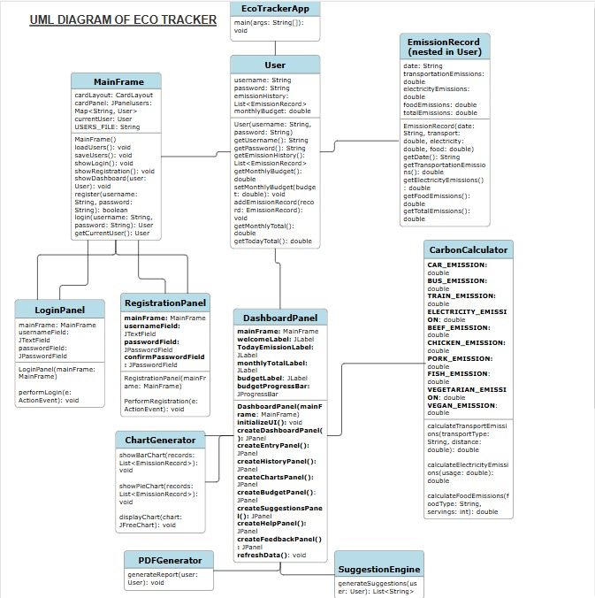

Relationships
Relationship | From | To | Description
Composition | mainFrame | DashboardPanel | Dashboard exists only within MainFrame
Aggregation | UserEmission | Record | User contains emission records
Dependency | DashboardPanel | CarbonCalculator | Uses for calculations
Association | LoginPanel | MainFrame | Calls login methods

4. System Design
4.1 Class Responsibilities
Class | Responsibility
MainFrame | Manages navigation between panels
User | Stores user data & emission records
CarbonCalculator | Computes CO₂ emissions
ChartGenerator | Creates bar/pie charts
PDFGenerator | Exports data to PDF
SuggestionEngine | Provides eco-tips

4.2 Key Algorithms
- CO₂ Calculation
  - Transport: distance × emissionFactor
  - Electricity: kWh × 0.5kg CO₂
  - Food: servings × foodTypeFactor
- Budget Tracking
double percentage = (monthlyTotal / budget) * 100;
if (percentage > 90) → "Warning!"
5. Implementation
5.1 Technologies Used
- Frontend: Java Swing
- Charts: JFreeChart
- PDF Export: OpenPDF
- Data Storage: Serialization

6. Testing and validation 6.1-
Scenario | Input | Expected Output
Car travel 50 km | "Car", 50 | 10 kg CO₂
100 kWh electricity | 100 | 50 kg CO₂
Beef (2 servings) | "Beef", 2 | 5 kg CO₂

6.2 Edge Cases Handled
1- Empty user inputs
2- Negative values in calculations
3-Concurrent access to user data

7. Conclusion
EcoTracker successfully provides:
1- A user-friendly carbon footprint tracker.
2- Data-driven insights via charts & reports.
3- Actionable suggestions to reduce emissions.

8.Future Improvements
- Cloud sync for multi-device access.
- Social comparison features.
- Machine learning for smarter suggestions.

9.Appendix
- Maven Repo , Tools – smart Draw(UML)
- Libraries Used: JFreeChart, OpenPDF
- Java Version: 11+

